Installing Mendix

1. Once you install the Visual C++ 2013 Redistributable (x64) then only **Mendix** will allow installing the Modeler.

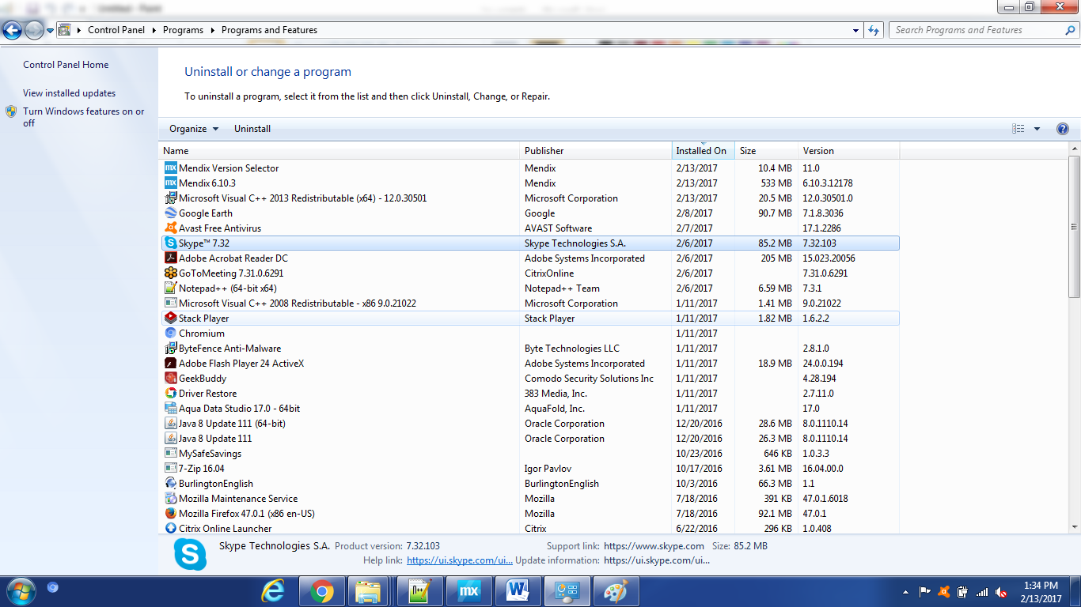

1. Modeler will be launched and look like this once you login –

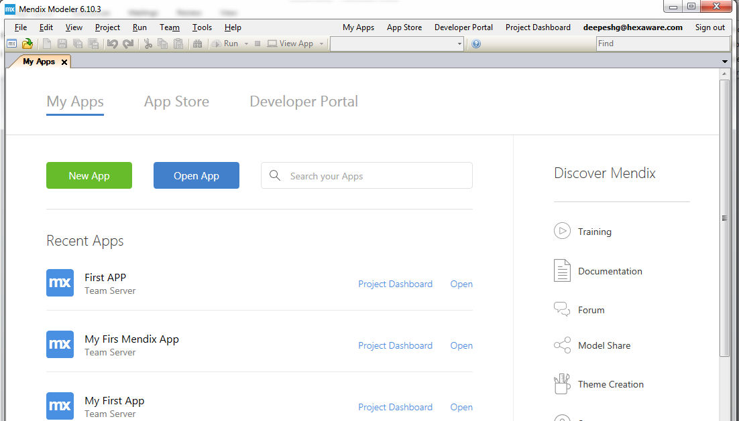

1. Create New App or open an existing app, it will send that information to it’s repository

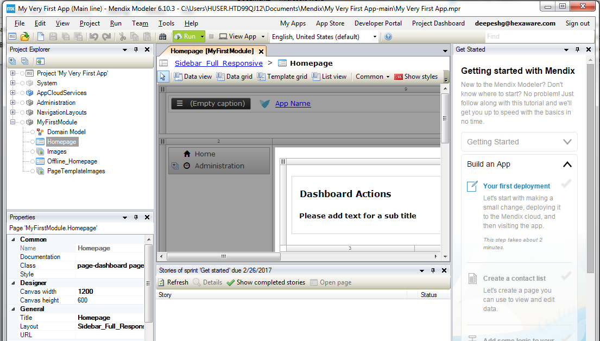

1. Once you do some modifications, it will check, deploy and run

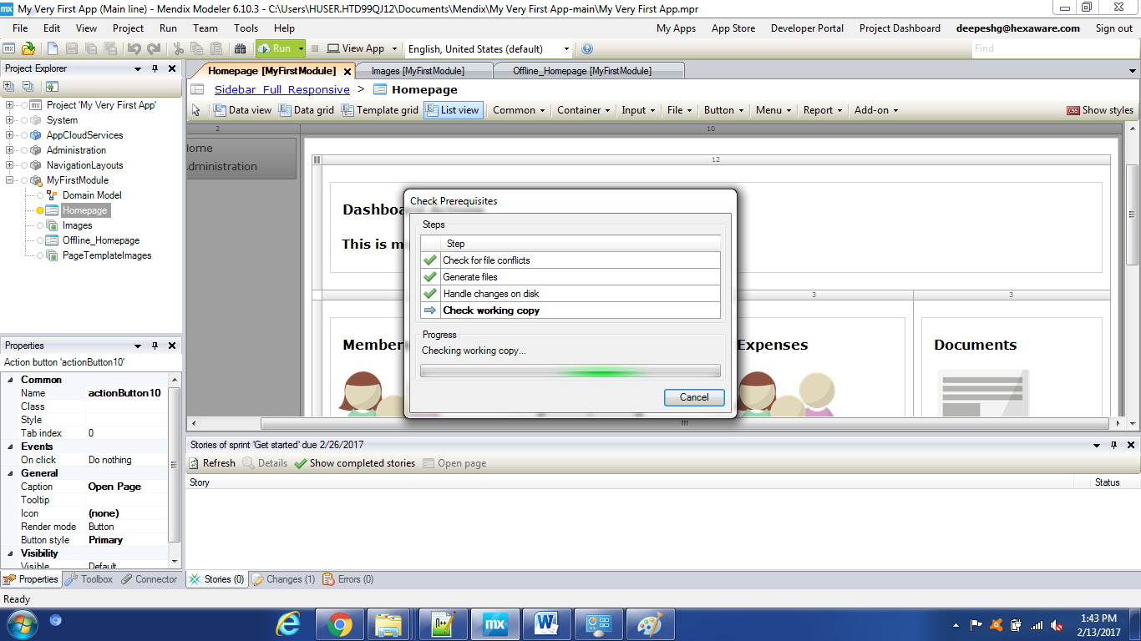

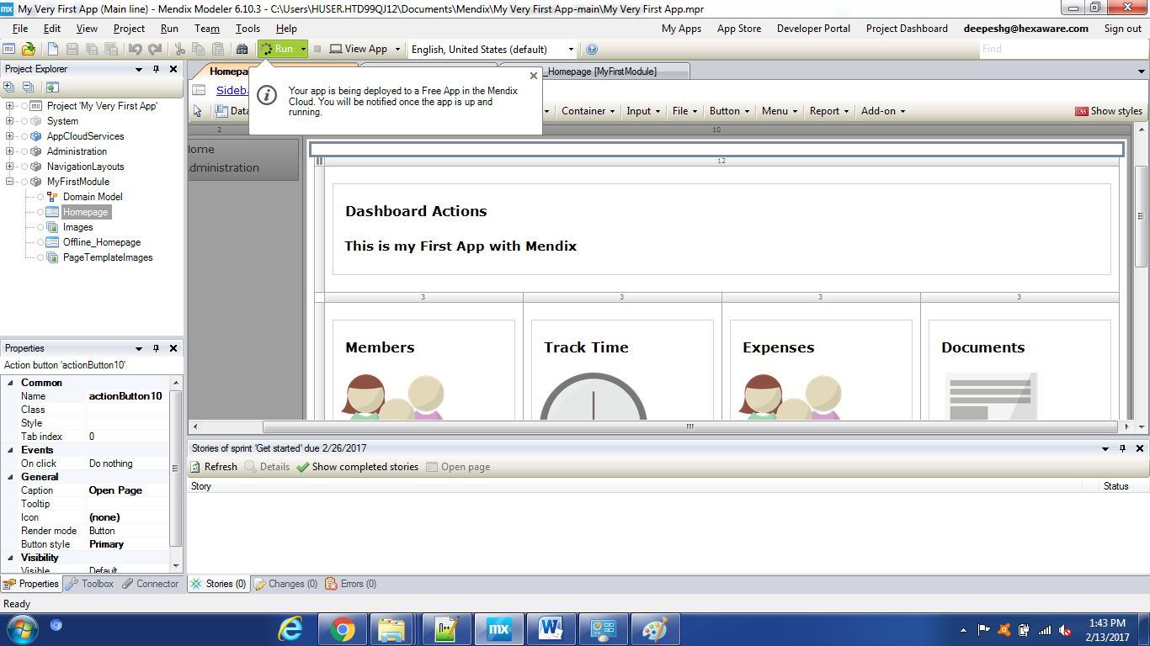

1. You can choose ‘Run Locally’ also -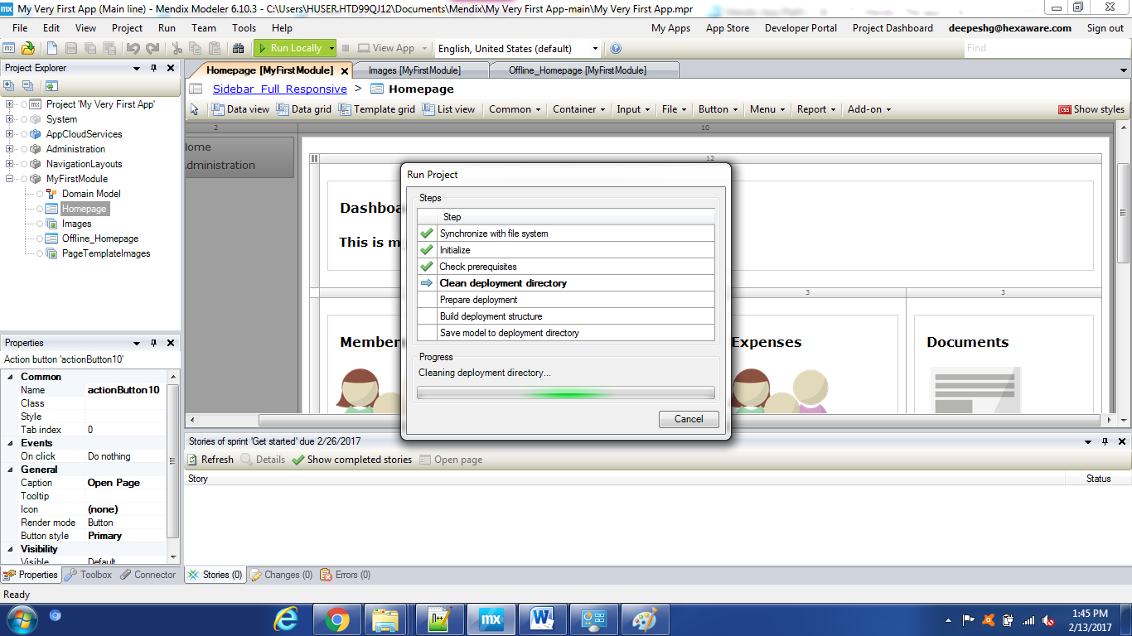
2. It will ask you to create ‘default’ database and then deploy your app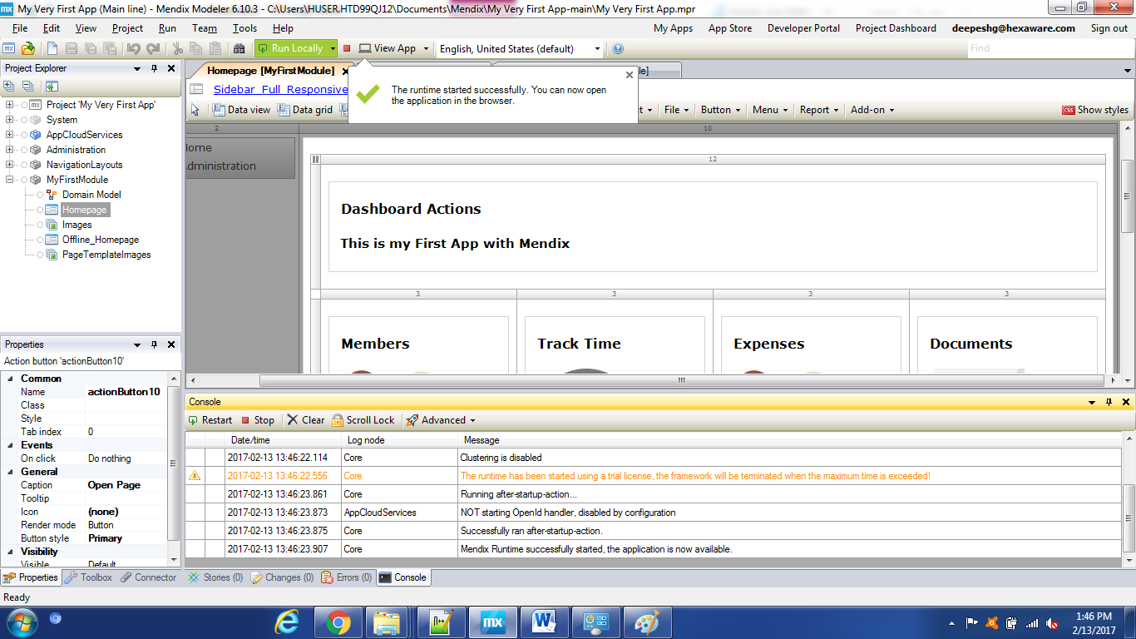
3. Click on View App which will take you to the Browser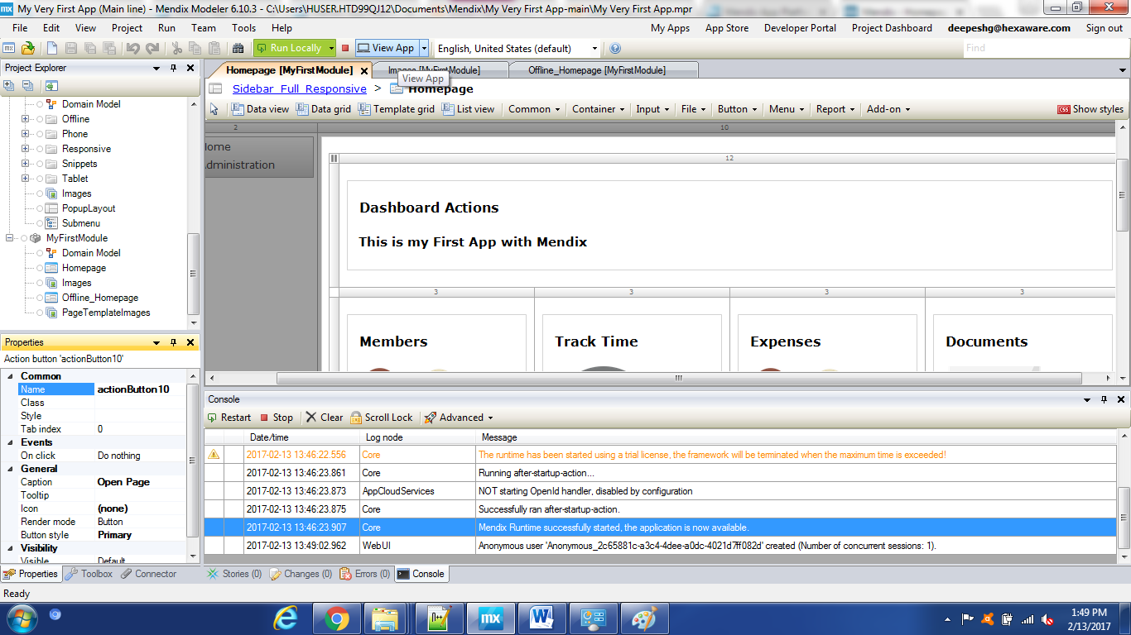

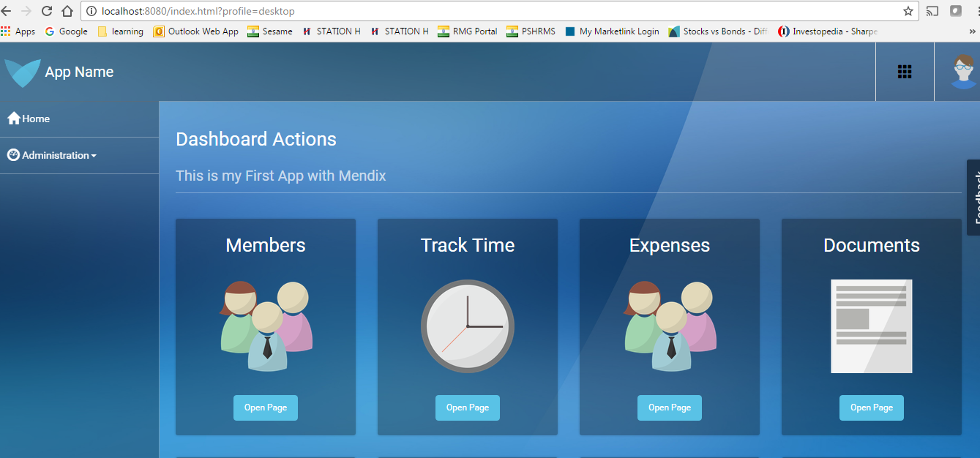

1. Adding Page with privileges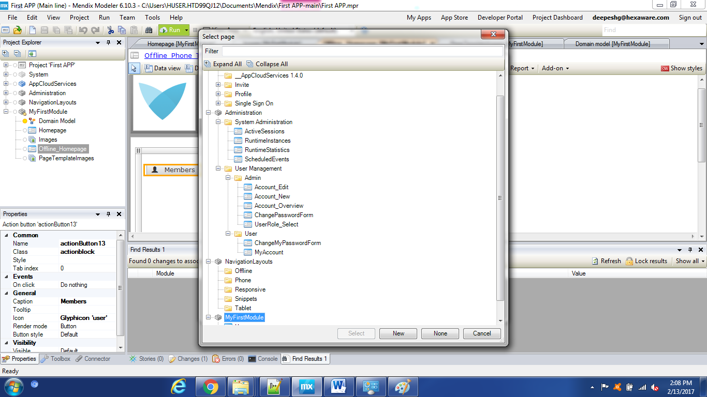
2. Creating domain Entity